Heart Disease Prediction System

🧩 Step 1: Problem Statement
🎯 Goal:
To develop a Machine Learning model that can predict whether a person is likely to have heart disease based on their medical attributes.
This problem is a binary classification task —
we are predicting two possible outcomes:
- 1 → Heart disease is present
- 0 → No heart disease

💡 Why This Problem Is Important:

Heart disease is one of the leading causes of death globally.
Early prediction helps doctors and patients take preventive steps.

As data scientists, our role is to analyze patient data (like age, blood pressure, cholesterol, etc.)
and use ML algorithms to find patterns that can detect risk automatically.

Type of Machine Learning Problem:

✅ Supervised Learning — because we have input features (like age, cholesterol, etc.) and a known output (target = disease/no disease).
✅ Classification Problem — because the output is categorical (1 or 0).

- outcomes

🗂️ Step 2: Overview of the Dataset

We’re using the Heart Disease UCI Dataset, which is one of the most popular datasets for health prediction problems.
This dataset was originally collected from Cleveland Clinic (USA) and is widely used in ML research.

📊 Dataset Details:
- Total Samples (Rows): 303 patients
- Total Features (Columns): 14
- Target Column: target (1 = disease, 0 = no disease)

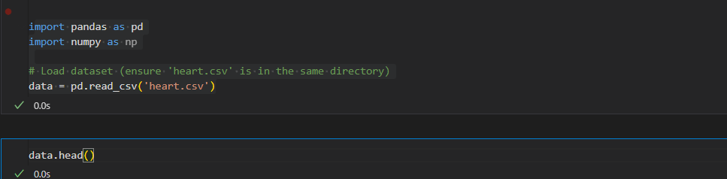
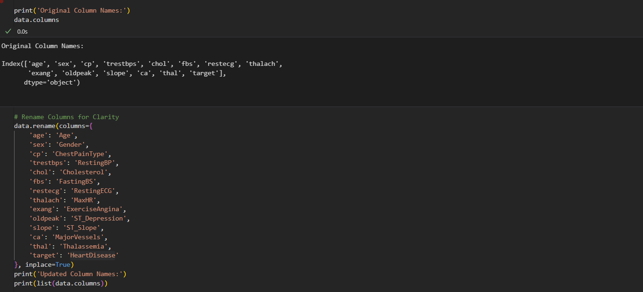
data

# Step 2: Data Cleaning & Preprocessing
#In this step, we will clean the dataset and make it ready for modeling.
# We'll check for missing values, duplicates, incorrect data types, and outliers.
# Proper cleaning ensures our machine learning model is trained on reliable data
import pandas as pd
import numpy as np
import seaborn as sns
import matplotlib.pyplot as plt
# Display basic info
data.info()
# 1️⃣ Check for Missing Values
data.isnull()
# Count missing values in each column
data.isnull().sum()
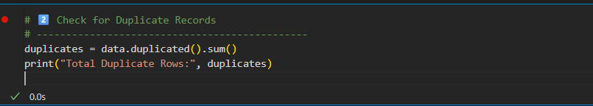
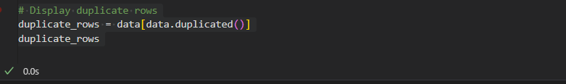
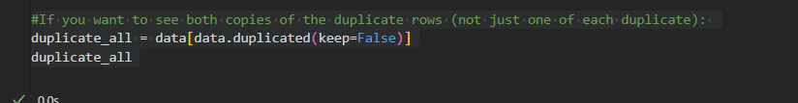
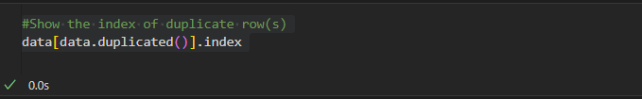

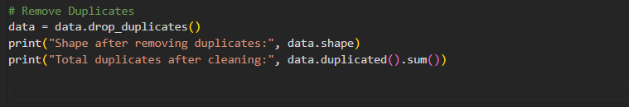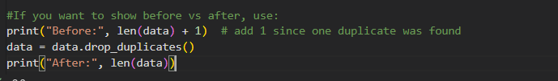
# 3️⃣ Verify Data Types
data.dtypes
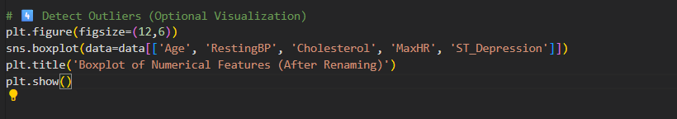
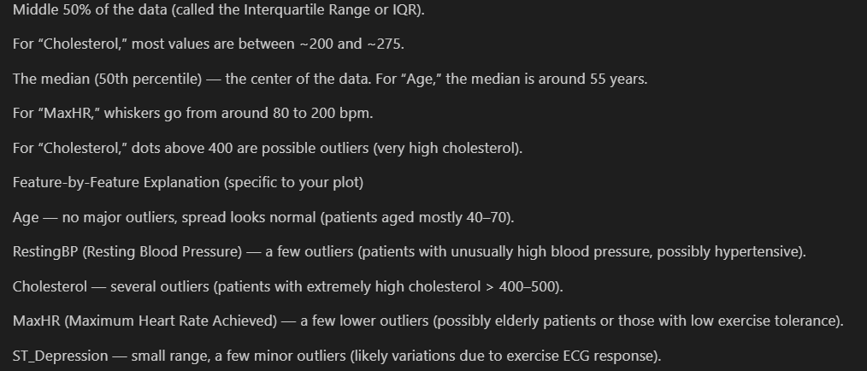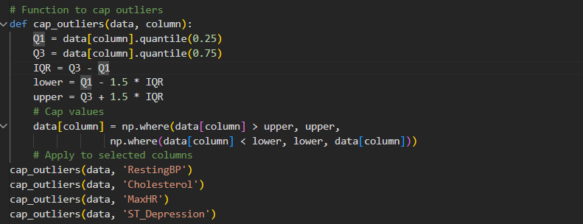

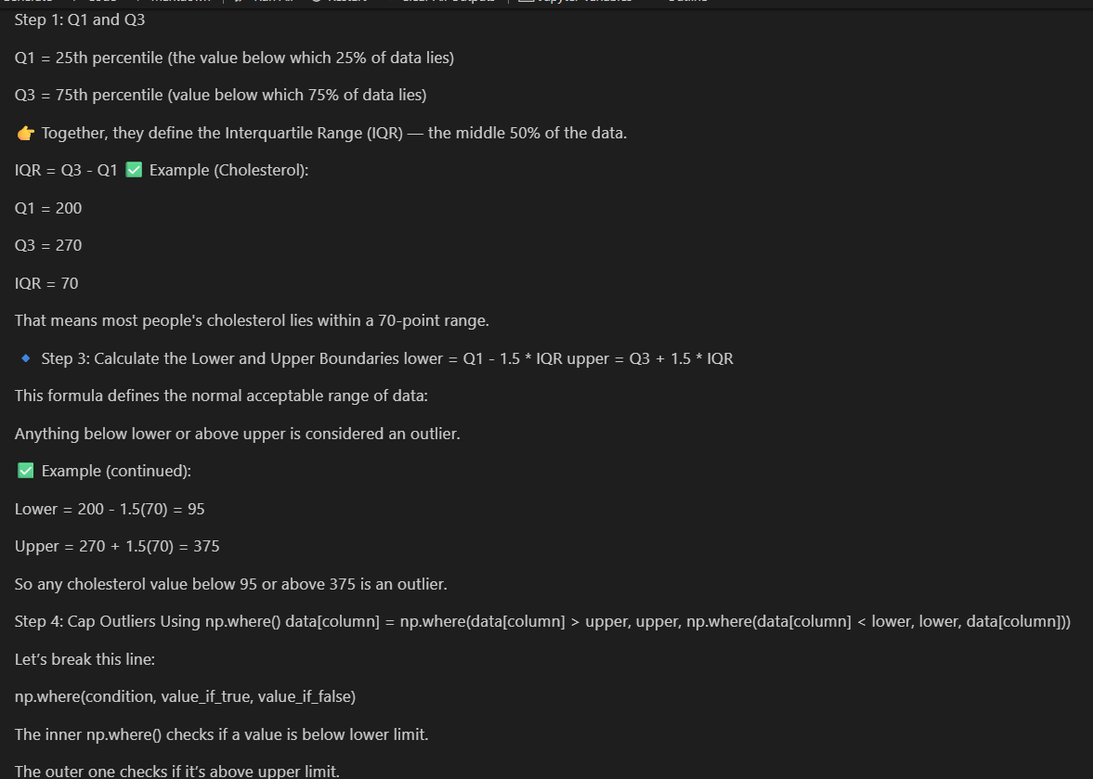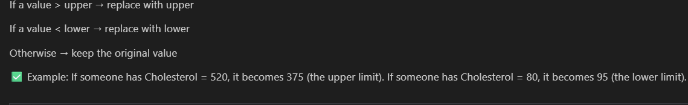
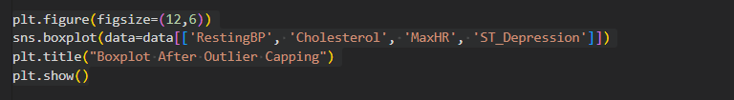
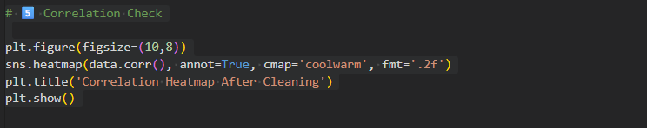
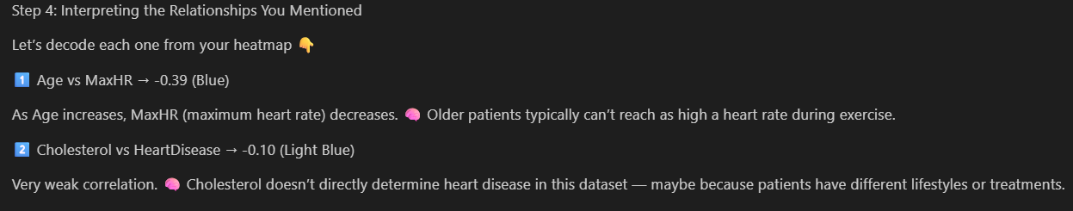
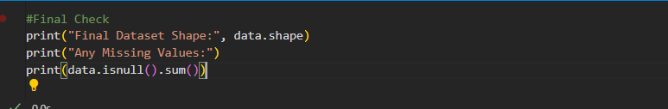
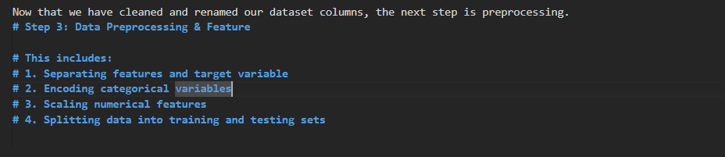
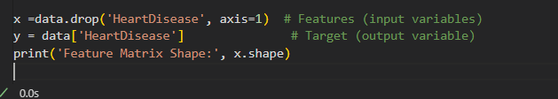
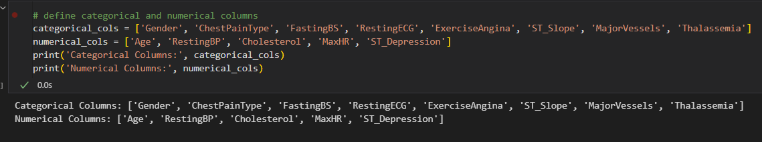
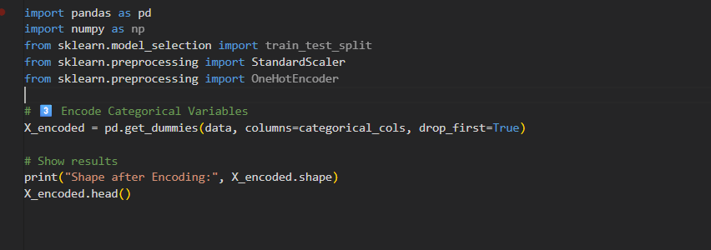
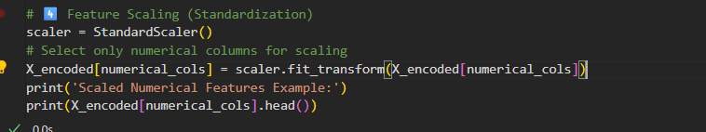
# # 5️⃣ Split Dataset into Training and Testing Set
